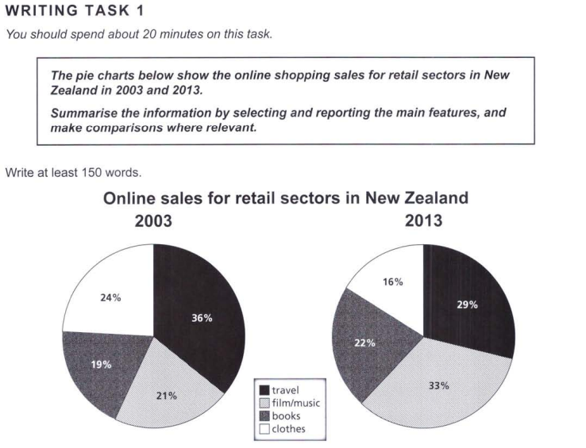

Essay Response:

The given pie charts depict the proportions of different retail sectors’ sales in New Zealand, in the years 2003 and 2013. It is important to note that no inferences can be made about absolute values, and that all quantities shown could be spoken of using percentage points, and with relation to each other.

Firstly, films and music have seen a big increase in their sales relative to all the other sectors, climbing 12 percentage points. Books have seen a similar increase, albeit only by 3 percentage points. Retailers of these products may have decreased revenues, but both sectors have made strides in relation to the tourism and clothing industries.

Secondly, tourism and clothing earnings reduced by 7 and 8 percentage points respectively, having similar relative drops in their sales. Furthermore, book sales have surpassed that of clothes, and the film/music industry has soared past tourism as a source of revenue in retail between 2003 and 2013.

In conclusion, in terms of the relative values of their sales, two retail sectors, namely, films/music and books, saw an increase in New Zealand. Together, they went from constituting about 40% of the sales in 2003, to around 55% in 2013. Meanwhile, clothes and travel are observed to have declined in this regard.